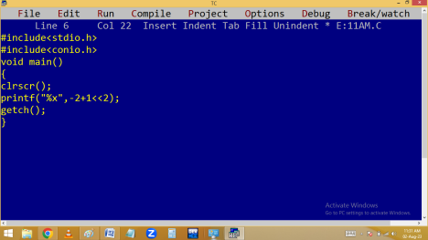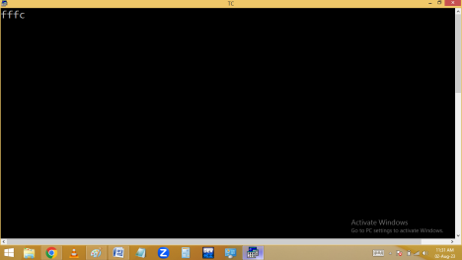
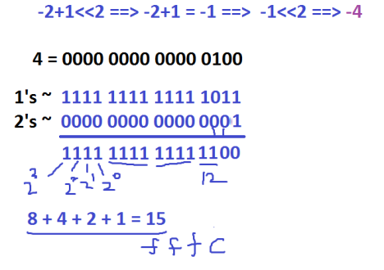
Variables:
Variable is a container is used to store the values inour programs.
Variable is a named memory location where we can store and manipulate [ modify ] the values in our programs.
Always the variables created in primary memory i.e. RAM Only. Hence the variables are temporary.
In C compiler we have to declare the variables at the first line of any function. In C++ we can declare anywhere.
Variables are case sensitive. i.e. lower and upper are different.
int a=10, A=200;
every variable is having 2 stages.
1.Variable declaration / declared
Eg: int a;
2.Variable initialization / defined
Eg: a=100;
When a variable is initialized then only memory allocated.
Syntax:
datatype variable[=value], variable[=value],….; Eg:
int id=1234, children;
char name[ ]=”Ravi”, gender=’M’;
float height = 5.8;
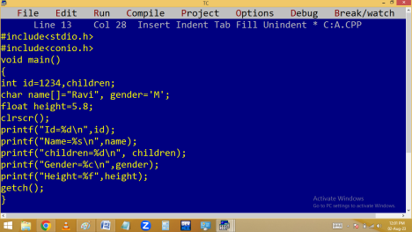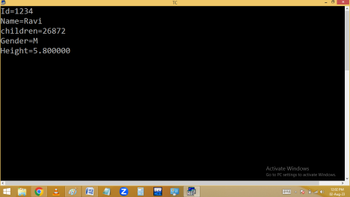Memory allocation for variables:
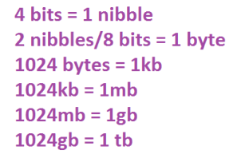
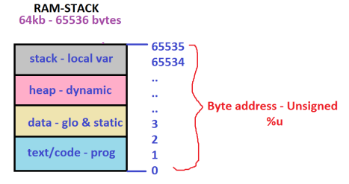
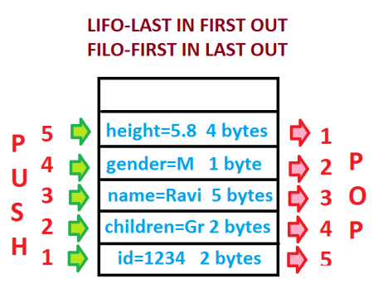
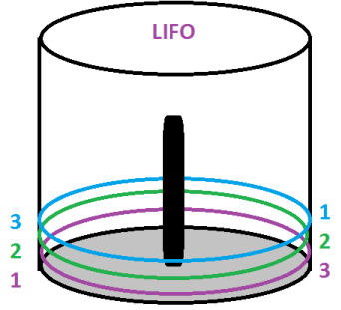Eg. Finding area of a triangle.
Formula - 0.5 * base * height
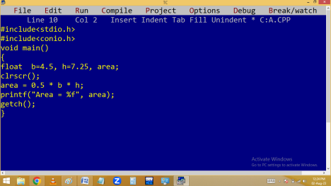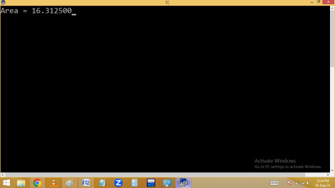
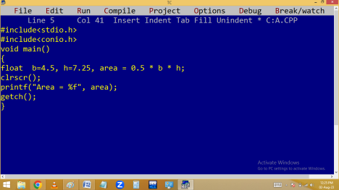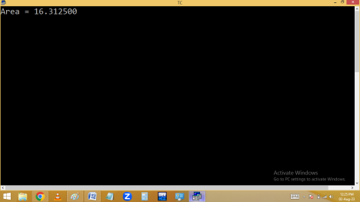
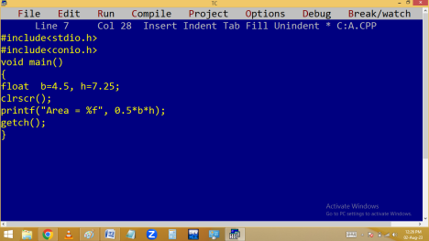Finding cube value.
a cube is a*a*a
Finding sqrt of given no using sqrt():

